A Qualitative Comparison of NS3 and Select Network Simulators: OMNeT++, Cisco Packet Tracer, and GNS3

James Kielson S. Cipriaso
College of Computer Studies
De La Salle University
Manila, Philippines
james_cipriaso@dlsu.edu.ph
Gebromel A. Yparraguirre Jr.
College of Computer Studies
De La Salle University
Manila, Philippines
gebromel_yparraguirre@dlsu.edu.ph

Abstract—This paper evaluates NS3 alongside three prominent network simulation tools: OMNeT++, Cisco Packet Tracer, and GNS3. Network simulators are indispensable in both academic research and industry, enabling professionals to model, test, and analyze complex network environments virtually. Wired Ethernet is employed as the standard medium across simulation scenarios to ensure consistency and reliability in the evaluation process. While NS3 is a widely used packet-level simulator, OMNeT++, Cisco Packet Tracer, and GNS3 each offer unique capabilities tailored to specific networking scenarios. This study compares these tools based on key metrics: ease of use, tool capabilities, and typical use cases. By conducting standardized scenarios and multiple runs, we ensure result reliability. The findings highlight the specific advantages of each simulator and suggest ideal applications, assisting in selecting the most appropriate tool for particular network simulation requirements.

Introduction
Network simulators are essential tools for academics and professionals, enabling the design, modeling, and testing of complex network infrastructures without the need for physical hardware. Among the leading network simulators, NS3 is renowned for its robustness and flexibility, particularly in packet-level simulations. Other simulators, such as OMNeT++, Cisco Packet Tracer, and GNS3, offer specialized functionalities tailored to specific networking scenarios. OMNeT++ is highly modular, making it suitable for simulating intricate networked systems. Cisco Packet Tracer is optimized for educational purposes, providing a user-friendly interface for learning networking concepts. GNS3 supports comprehensive emulation of real devices, making it valuable for practical network training and testing.
In this study, we adopt wired Ethernet as the standard transmission medium for all simulations to maintain uniformity and ensure a fair comparison of tool capabilities. This choice reflects Ethernet's ubiquity in networking environments and its relevance in both academic and practical applications. The paper compares and contrasts four main network simulation tools: NS3, OMNeT++, Cisco Packet Tracer, and GNS3. We evaluate their performances based on three essential metrics: ease of use, tool capabilities, and typical use cases. The results of this study will present the comparative strengths and limitations of each tool, supporting researchers and practitioners in selecting the most appropriate simulator for specific applications. The practical insights derived from our findings aim to assist in both academic and applied research within the field of network simulation.

Review of Related Literature (RRL)
Several comparison studies on network simulation tools have provided essential statistics that enable performance assessment. Several network simulation tools allow researchers and practitioners to pinpoint appropriate tools for specific applications. The paper titled "A Comparative Study of Various Network Simulation Tools" by Arvind T comparatively evaluates NS2, NS3, OPNET, OMNeT++, J-Sim, and QualNet along with parameters such as GUI support, user-friendliness, simulation performance, and scalability. These metrics relate to the strength of every tool, with NS3 indicating flexibility when Python support is available; OPNET, for the reason it simulates very fast and has real-time interaction; and OMNeT++, for modularity with GUI quality; therefore, the most appropriate tool depends on the complexity and user-friendliness needed [1].
In the paper known as "A Performance Comparison of Network Simulators for Wireless Networks," Khan, Bilal, and Othman present an analysis of NS2, NS3, OMNeT++, and GloMoSiM using metrics tailored to specific contexts of wireless networks, which include CPU utilization, memory consumption, computational duration, and scalability. Using these metrics, the authors conclude that NS3 and OMNeT++ offer better performance in wireless simulations, offering significant resource efficiency and the ability to scale up. At the same time, GloMoSiM only consumes minimal resources but has limitations on scalability for larger configurations of networks [2].
Kabir et al., "Detail Comparison of Network Simulators" also compare the available tools, underlining licensing, type of simulation events, discrete or continuous modules, GUI support, scalability, and parallelism. These criteria allow flexibility and accessibility to be tracked in every simulator. However, then NS3 and OMNeT++ are relatively economical alternatives to open-source simulators. OPNET and QualNet are the best in simulation speed and modularity, suited for extensive networks and high-demand applications [3].
A Performance Comparison of Recent Network Simulators" by Weingärtner, vom Lehn, and Wehrle is a performance comparison of NS2, NS3, OMNeT++, SimPy, and JiST/SWANS based on runtime performance and memory utilization. Here, it is identified that aside from effective memory management with optimal runtime performance, both NS3 and OMNeT++ are also a good choice for complex and vast simulations. JiST/SWANS is also known to consume memory efficiently, which is why it can be used in wireless networks. On the other hand, SimPy's high usage of memory and the reduced runtime performance limit large-scale applications [4].
Venkataramanan and Lakshmi in their work on 2018 have studied a number of wireless network simulation tools in order to be able to apply them on LTE networks. The right simulator, they say is the basis for the prediction and evaluation of the mobile network performance. They have categorized the simulators under commercial which include the use of OPNET and QualNet, and then those open source which include use of NS3 and OMNeT++. They have highlighted key performance metrics as scalability, flexibility, support in documentation and accuracy in simulation. Packet-level accuracy along with flexibility was the main features of NS3, whereas modular structure was the reason for praise of OMNeT++. Next, the authors discussed hardware co-simulation, especially with FPGAs, about achieving accurate simulation. In conclusion, the authors stated that depending upon the particular requirement of a project, scalability, flexibility, and hardware integration may be the basic requirement to have an accurate and efficient outcome from simulators [5].
According to the literature, some key metrics that need emphasis in GUI support are scalability, simulation speed, CPU and memory efficiency, and ease of use, which must be considered when measuring network simulators.
The above metrics serve as the foundation of the methodological approach of this research, in which we attempt to do a comparative analysis of NS3, OMNeT++, Cisco Packet tracer, and GNS3. The evaluation of each simulation tool based on performance criteria adopted for the study hopes to enrich existing literature and provide valuable references to researchers and practitioners to identify the apt simulator for distinct network contexts.

Network Simulators

NS3
NS3 is an open-source, discrete-event network simulator written in C++ and released with an initial version in 2008. It was developed as the successor to NS-2, as that simulator had quite some shortcomings and limitations. In that respect, it offers improved modularity and significantly better capabilities for scalability. Developed by Nortel, with its first release in 2008, NS3 provides Python bindings for work in a script-based environment [6].
Functionally, NS3 works through discrete event simulation. This means that when the packet arrives or protocols engage with other entities, NS3 works sequentially. It supports various models and protocols ranging from wired to wireless networks, which makes it suitable for low-level packet simulations [6].
Applications of NS3 In academic and research organizations, the NS3 tool is found to be very popular for simulating internet protocols, wireless networks, and vehicular networks. Data accuracy in packet-level simulation is great for prototyping new protocols and technologies in a controlled environment before their actual deployment in real life [7].
Although its capabilities are quite good, NS3 has a high learning curve, especially if the user has never programmed or only a little in C++. Also, considering the full level of modeling possibilities, simulation installation may take more time and require more computation power [7].

OMNeT++
The OMNeT++ is a modular, component-based simulation library and framework that was mainly developed for network simulation. Released in the early 2000s by András Varga, it has attracted far-reaching attention from academia and industries in research with its high degree of modularity and versatility. The simulator is constructed in C++. Due to this, it is flexible with modeling and development of simulation that has led to its use in a wide range of research fields [8]. OMNeT++ is component-based architecture that enables users to build the simulation of a system by using only connectible modules, representing network entities such as routers, switches, or even end systems. Users are free to personalize or extend these modules for special needs on research. The simulator also includes an extensive graphical user interface, easing the design, visualization, and debugging of network models [8].
OMNeT++ is very popular in general for all types of network simulations, whether it is wireless networks, sensor networks or internet protocols. With its modularity and extensibility, it is becoming a popular choice as a project platform for applications like the Internet of Things, vehicular networks, or distributed systems. Since it is flexible, it is often chosen for a research project based on a customizable and visually supported simulation environment. [9]
While OMNeT++ is highly user-friendly through its GUI and modularity it does not scale as well as several other simulators to very large-scale networks which could be a problem for extremely complex simulations and limit their performance. In addition, some of the more advanced simulation capabilities have to be created through modules or add-ons that can make setup difficult and increase configuration time to set up the simulation [9].

  - Cisco Packet Tracer
Cisco Packet Tracer is the network simulation tool, developed by Cisco Systems, facilitating students in better learning of the subjects present in networking. It is an application where a user can design, set up, and troubleshoot virtual networks with simulated equipment that includes routers, switches, and client devices. It is particularly helpful for those who aspire to have some form of Cisco certification since the tool provides them with an appropriate scenario to test theoretical knowledge [11].
Functionally, Packet Tracer presents an intuitive interface marked by drag-and-drop elements in the design of complex network topologies. It supports a variety of protocols and technologies, allowing for simulation of both wired and wireless networking environments. The application runs in two main modes: real-time mode, which emulates genuine operations of the network device; and simulation mode, which permits users to monitor and manage data packets' movements in the network. Such dual-mode operation helps explain the dynamics of a network [11].
There are a few negatives to the advantages listed above. The main one is that Packet Tracer, as a simulation tool, does not closely represent the functionality of real network devices. Some features and protocols that exist on real hardware are either not implemented or work quite differently in this simulation. Beyond this, Packet Tracer is an effective learning tool but is no replacement for hands-on experience with real networking equipment [12].

GNS3
GNS3 or Graphical Network Simulator-3 is an open-source network emulator that was invented in 2008 by Jeremy Grossmann. According to the source [12], GNS3 allows its users to emulate and test virtual and real devices in a graphic environment. The main reasons for GNS3's popularity among networking professionals are due to its fully featured graphical user interface as well as using real Cisco IOS images besides other network appliances. GNS3 maps the complex network topology, using drag-and-drop interfaces by connecting virtual devices, such as routers, switches, and firewalls. It relies on the emulation tools like Dynamips, QEMU, and VirtualBox but offers real-device emulation that can be used alongside virtual network appliances [12].
GNS3 is widely used in network design, testing and training, and, particularly, to prepare for Cisco certification. It allows network administrators to simulate real-world configurations and troubleshooting networks without the physical hardware, making it a resource of much value for learning and practical application [12]. A well-known negative aspect of GNS3, however, is that it is resource-intensive, requiring fairly large sums of CPU and memory, especially when emulating several devices or complex topologies. Configuring and getting real device images up and running could be notoriously complicated and therefore a rather steep learning curve for new users to use [12].

Hands-On Testing Methodology

Tool Setup and Testing Environment
Each tool will be tested following the researchers’ testing metrics after which, a tool will be chosen to represent a metric . The testing environment of the tools will differ in one aspect, operating system. NS3 requires Linux in order to be used while the other three network simulators are able to run seamlessly on Windows. The difference in operating systems will affect the comparison of the simulators’ accuracy, performance, and speed leading to an unequal comparison. To avoid this issue, the comparative analysis will be purely qualitative and focus on the network simulator’s ease of use, abilities, and possible use cases.

Testing Metrics
In comparing NS3 with the three chosen Network Simulation Tools, the study will focus on these three primary metrics.

- Ease of Use
- Each Network Simulation Tool will be judged by their ability to be easily understood when it comes to actually using the tool, and whether someone who is considered a beginner can learn and master the tool fairly easily..

- Tool Abilities
- Each tool will be checked for their ability to simulate network scenarios based on their assigned protocols. Each will be judged for their realism in simulating networks as well as their way of presenting information.

- Use Cases
- The scenarios that the tool can be used for are checked as well. This is so that the researchers can determine which tool can be best utilized for a specific network simulation scenario.

  - Testing Proper

Network Simulator 3 (NS3)
Considered as a powerful and widely used network simulation tool for academic purposes, NS3 provides accurate and detailed simulations of networking systems.
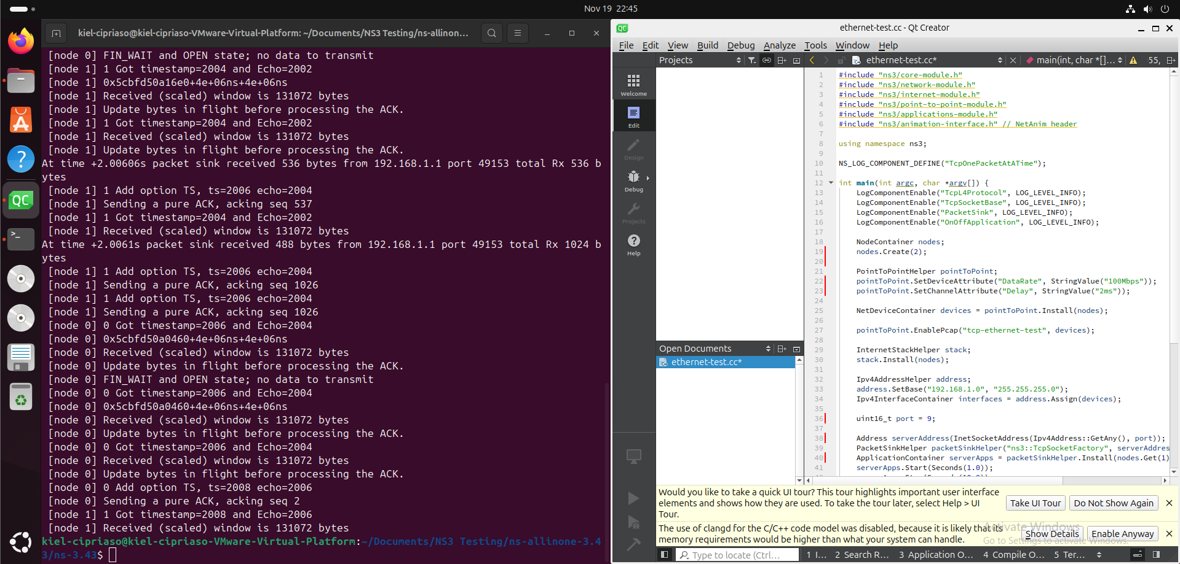
Figure 1.0: NS3 Interface

- Ease of Use
NS3 is a feature-rich and flexible network simulator working natively only on Linux systems. NS3 is open source with each part of the tool being completely modular making it the best choice for the study of many different network simulation scenarios. However, the ease of use of this simulator ultimately depends on the user’s experience with network systems and programming. While making a baseline simulation script, the researchers were able to find a number of tutorials, and sample scripts online. The NS3 website also has an extensive documentation that the researchers were able to use as reference. When making a baseline simulation, experience programming with C++ language is crucial with NS3, which requires all scripts to be written in this language. This may be challenging for beginner programmers, but past the learning curve, experienced network analysts may find NS3 comfortable to use with its easy to manage customizations, modular design, and flexibility. Overall, NS3 remains to be one of the most used network simulation tools due to its flexibility and modular design. Based on the researchers’ experience with the simulator, it may be challenging for beginner programmers to use it but past the learning curve and with all the references found online, it becomes a powerful network simulation tool that could be used for a magnitude of network scenarios.

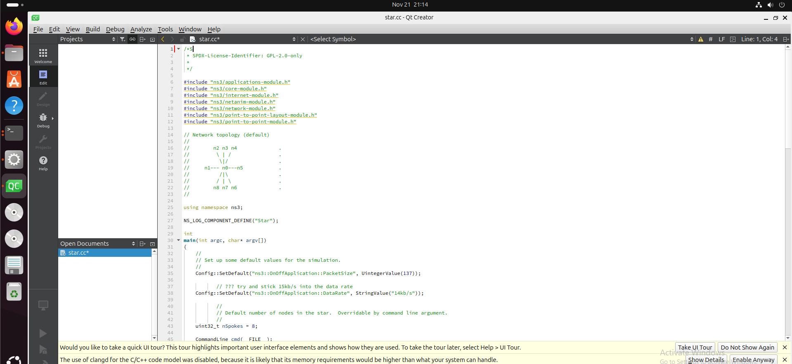
Figure 1.2: Wired ethernet NS3 script

- Tool Abilities
In testing NS3’s proficiency in network simulation, the researchers are able to utilize NS3’s sample scripts where both network tracing (NetAnim) and traffic analysis (.pcap) can be seen. Starting with network tracing, a sample script that goes by “star.cc” under NS3’s TCP wired ethernet examples, the script was modified by the researchers in order to implement NetAnim. In this network scenario, nine nodes can be observed with one node acting as the central hub of the wired network’s star topology. NetAnim has the ability to animate the sending and receiving of packets which greatly enhances the realism of the network simulation.

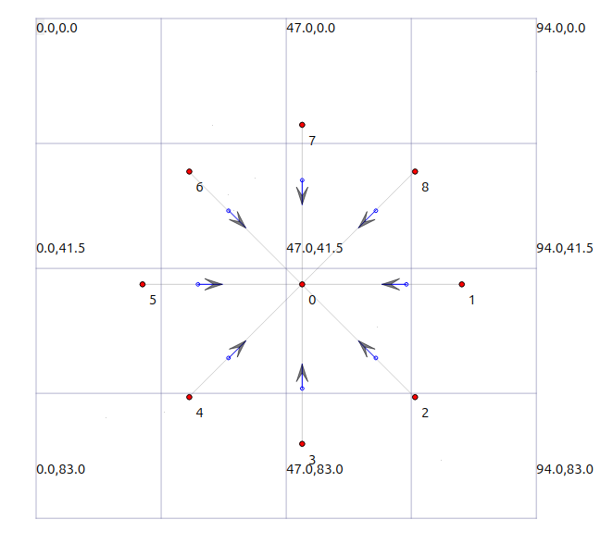
Figure 1.3: 8 nodes sending and receiving packets from central hub

In traffic analysis, this simulation also provided .pcap files to be analyzed, with the following .pcap files being a record of the node’s communication with the main hub.
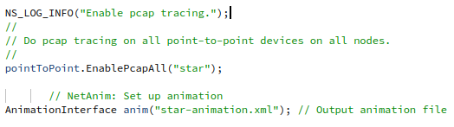
Figure 1.4: .pcap file generation is enabled for each node

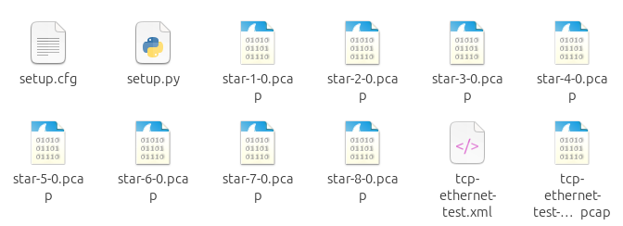
Figure 1.5: .pcap files generated by star.cc

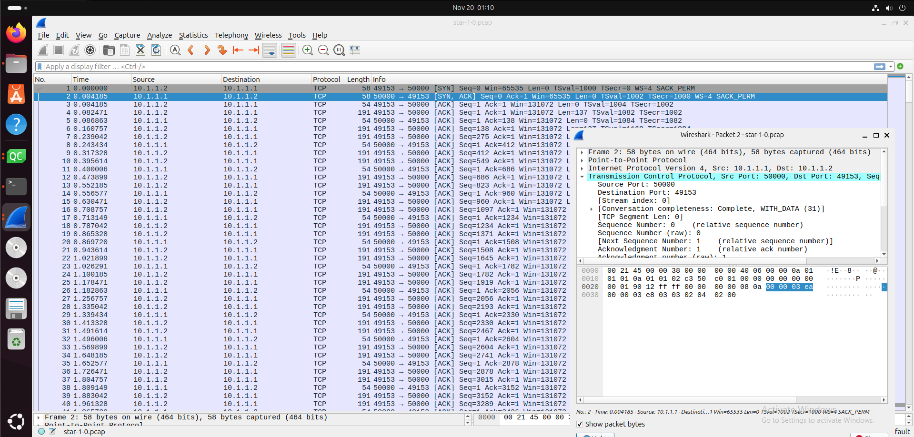
Figure 1.6: Contents of the .pcap file of node 1 communication
Along with the ability to view the network trace and traffic, NS3 is feature-rich to also have amassed a lot of different network modules used to ensure specific and accurate network scenarios. NS3 is an open source network simulation tool where developers can add their own modules and sample scripts for others to use. Overall, with the use of NS3’s NetAnim library and .pcap generator, not only could researchers observe the simulation work per design and have the results generated as .pcap file, developers within the computer networking community can also help in the advancement of the platform, allowing for continuous software support for NS3.

- Use Cases
Due to NS3’s modular and flexible architecture, the use-cases for this particular simulation tool is boundless, offering complete freedom on network simulation provided that the developer has an experience in networking and programming. Being an open source tool, developers can implement modules specifically made for a network scenario in which the researchers could then test. The sample scripts in NS3 serve as an educational tool for developers to make their own scripts for their own network projects, which in turn makes NS3 the most versatile network tool as of the current year.

Objective Modular Network Testbed in C++ (OMNeT++)
OMNeT++ is a widely used simulation framework, used for network research and development. It offers a moderately easy learning curve, a modular setup, and a key feature of having a dedicated Eclipse-based IDE configured with a graphical simulation interface allowing users to properly view within a network simulation.

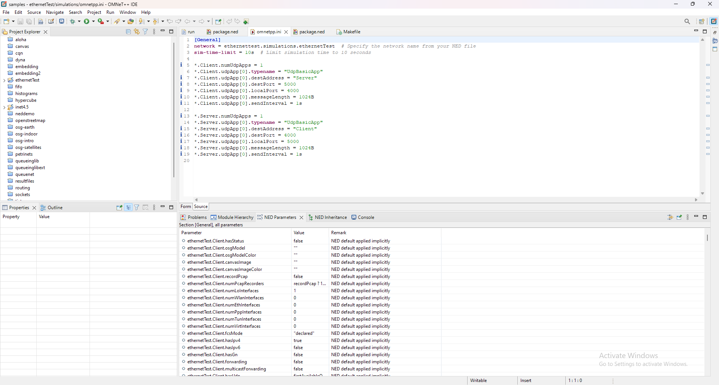
Figure 2.0: OMNeT++ Interface

- Ease of Use
Similar to the NS3, OMNeT++ has a lot of features that a simulation tool must have in order to simulate network scenarios. OMNeT++ uses the C++ language in creating projects which in the development, the ease of use of the framework is dependent on the user’s knowledge of the language. However unlike NS3, OMNeT++ improves upon this by having its own application IDE, allowing the user to manage projects seamlessly in-app. The biggest advantage of this tool over NS3 will be its own built-in graphical simulation interface where the user can view the simulation happening in real time while also seeing the network traffic appear on the interface below the simulation graphics, emulating that of the Wireshark interface. The OMNeT++ app works on Windows, Linux, MacOS, etc. which adds on to the tool’s ease of use by allowing multiple operating systems to support it. Finally, the tool provides a comprehensive documentation that could be found on their website along with their own video tutorials on YouTube, and a photo gallery of various sample scripts and simulation graphics done using the tool. Overall, OMNeT++ retains the sophistication of NS3 while improving upon the visualization and network modeling of NS3.

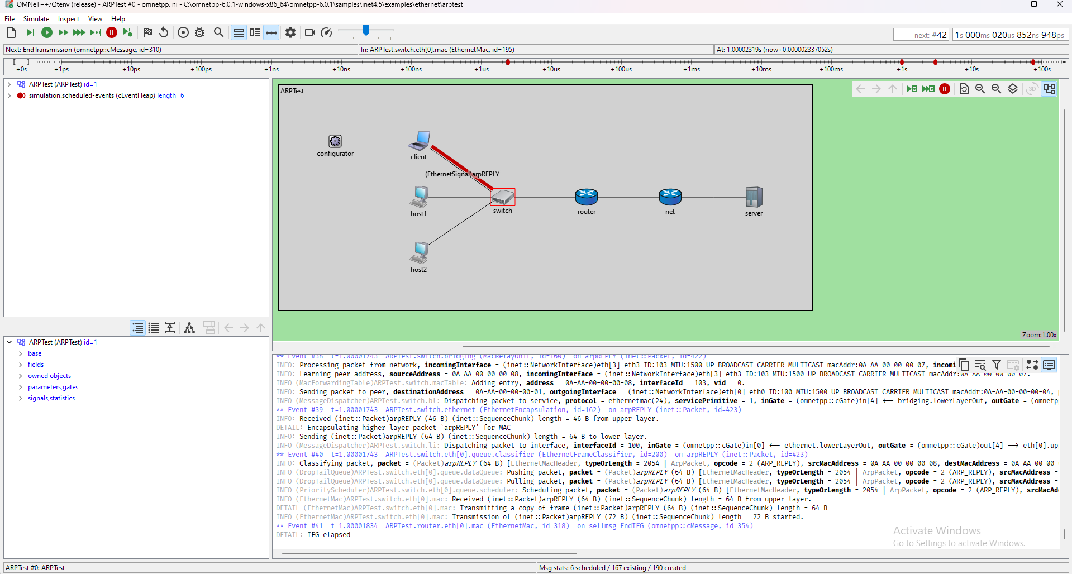
Figure 2.1: OMNeT’s built-in graphical simulation interface

- Tool Abilities
The capabilities of the OMNeT++ IDE when it comes to debugging surpasses that of NS3. The IDE, being based on the Eclipse IDE, is very user friendly. It offers syntax highlighting, code completion, and a seamless project manager, essential tools that could be found in modern IDE. Unlike NS3, OMNeT++ does not rely on external libraries in order to have graphical simulations for analysis, the graphical simulation interface automatically accomplishes these operations while also working in real time. However, the creation of .pcap files for traffic analysis must still be stated in the runtime parameters.

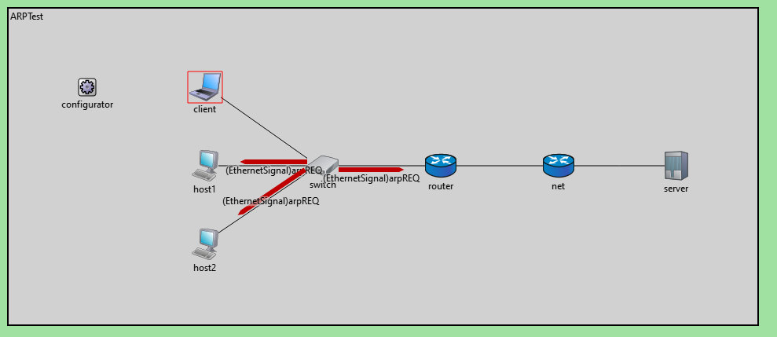
Figure 2.1: Sample wired ethernet script simulating Address Resolution Protocol (ARP)

Provided is an example of a sample script that aims to simulate an ARP test network which emulates ARP requests between devices including the sending of actual packets. A sample project comes with a .ned file, an omnetpp.ini file, and a results folder. The .ned file is a config file where the user is able to define the model and topology of the network. OMNeT++ provides the user with a palette of network modules (router, switch, end device, etc.) which they could then place and connect with other modules in the given network space. The omnetpp.ini file is also a config file where the user can modify the runtime parameters (ip addressing, source and destination ports, packet size, etc.). This is also where the developer can manage the creation of .pcap files. Finally, there is the results folder where the result files (.vec, and .sca) and the .pcap files are located. .vec and .sca files are the results of the simulation in both vector and scalar format, allowing for the results to be plotted in a chart.

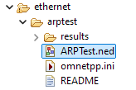
Figure 2.2: File structure of ARPtest sample project

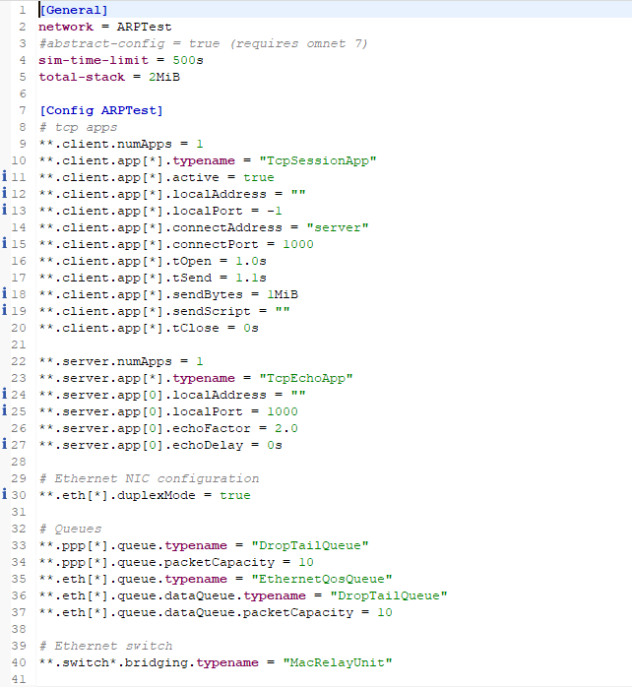
Figure 2.3: omnet++.ini file for ARPtest sample script

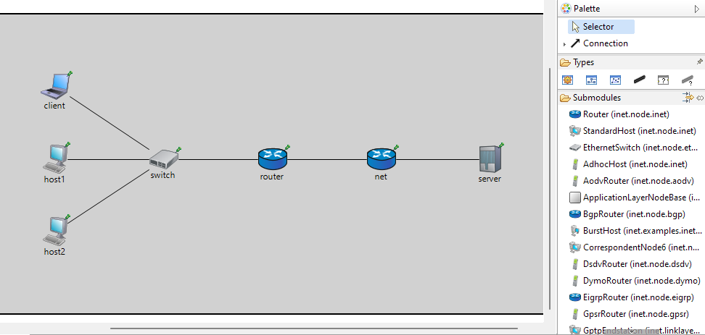
Figure 2.4: .ned file for ARPtest sample script

- Use Cases
OMNeT++ proved to be on the same level of sophistication as NS3 with the addition of a beginner friendly and easy to use simulation interface. Compared to the NetAnim library used by NS3, OMNeT++’s built-in graphical simulation interface has proven to be much more insightful and helpful along with the palette of modules that came along with it. Overall, OMNeT++ has the same capabilities as that of NS3, which allows for a wide range of use in network development. While remaining as challenging as NS3 with its use of C++ scripts, the quality of life introductions brought by OMNeT++ made network simulation easier and more efficient.

Cisco Packet Tracer
Cisco Packet Tracer is a high level network simulation tool designed for real-world simulation of networks. This network simulator has a gentler learning curve as compared with the other network simulators. This allows for Packet Tracer to be used in an educational setting. This network simulator uses Cisco proprietary devices in its simulation.
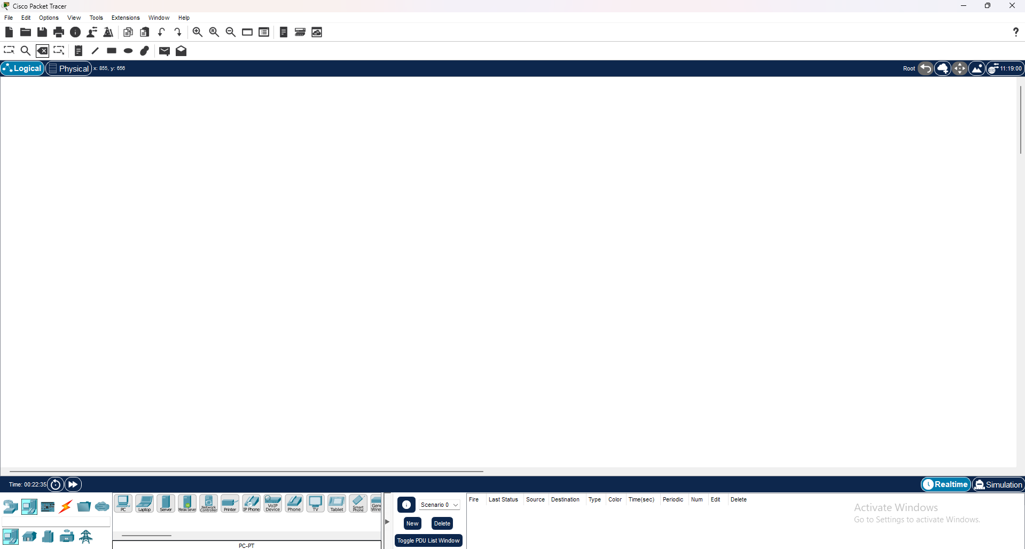
Figure 3.0: Cisco Packet Tracer Interface

- Ease of Use
Cisco Packet Tracer is one of the easiest network simulators to start simulating networks with. Upon opening the application, this tool allows the user to sign up for their networking academy as Cisco Packet Tracer is made partly for educational purposes. The tool itself may not be as sophisticated as NS3 or OMNeT++ but instead makes up for it with its high level network simulation. Similar to OMNeT++, this network simulator uses a graphical simulation interface when simulating a real time network, along with a list of modules (router, switch, end device, etc.) to place inside the given space. However, the main feature of this tool is its implementation of each module. The modules provided in this application are fully customizable, emulating the device from real life, an example of which is a PC module that you could add peripherals into (network card, headphones, microphone) as long as the device is powered down. The PC module could also be used similar to that of any PC, a user can use a web browser provided that a Server module is also set up. The level of customization differs from that of NS3 and OMNeT++ with Cisco Packet Tracer being a high-level network simulator. Overall, Cisco Packet Tracer was made with the intention of teaching networking basics to students, with the tool directing users to their Networking Academy for further study on networks.

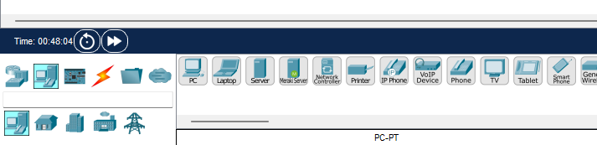
Figure 3.1: End Device Modules

- Tool Abilities
The previous network simulators rely on a script written in C++ in order to simulate network scenarios, in Cisco Packet Tracer however, no additional scripts are used or needed as the way this network simulator works is that it works on the level of emulated devices being formed into a network through modules and Packet Tracer’s GUI. Similar to OMNeT++’s .ned file, this tool has modules that could be dragged and dropped into the space, connected to each other, and then simulated. But the configuration for the network and the devices can be found in the device itself and not an external script. An example of this is the tool’s PC module where the developer could configure the PC’s hardware (peripherals), and software (IP Addressing, Web Browser, Terminal, etc.). This configuration of individual devices becomes the baseline for the type of network being simulated.

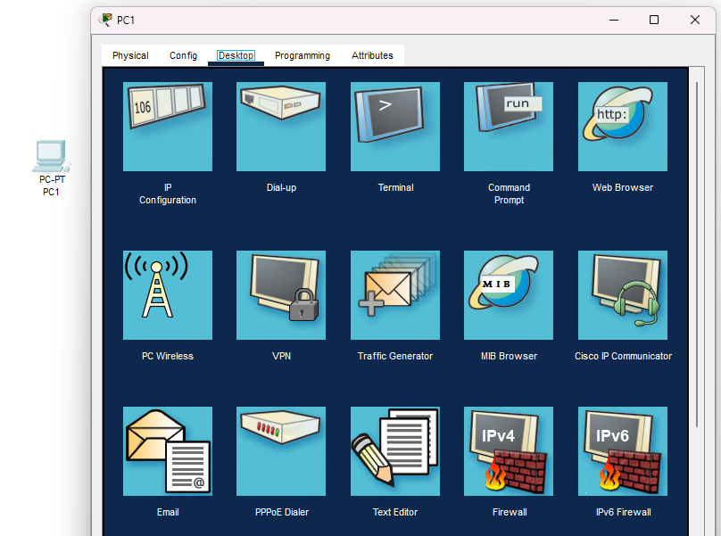
Figure 3.2: PC Software Configuration (Desktop)

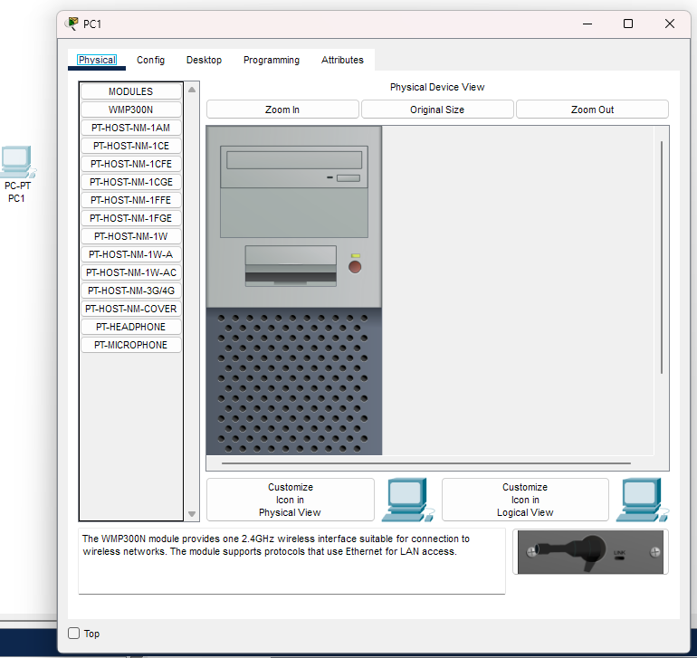
Figure 3.3: PC Physical Configuration (Peripherals)

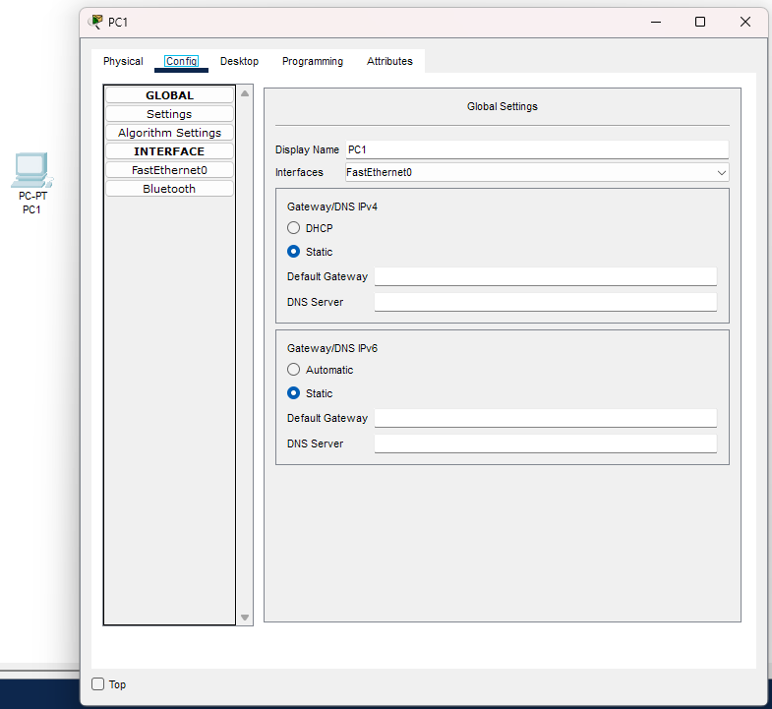
Figure 3.4: PC Physical Configuration (Ethernet Config)

The simulation segment of Cisco Packet Tracer relies on testing the connections of the network. In order to test the connection between devices, a PDU is used which is essentially a method to send packets between two devices. The packet could be modified to fit with a corresponding protocol (FTP, HTTP, SMTP, etc.) and be used to test the connection either wired or wireless. Sending a PDU from one device to another can be viewed in real time with Packet Tracer’s Simulation window where the PDU is shown traversing the network from one point to another.

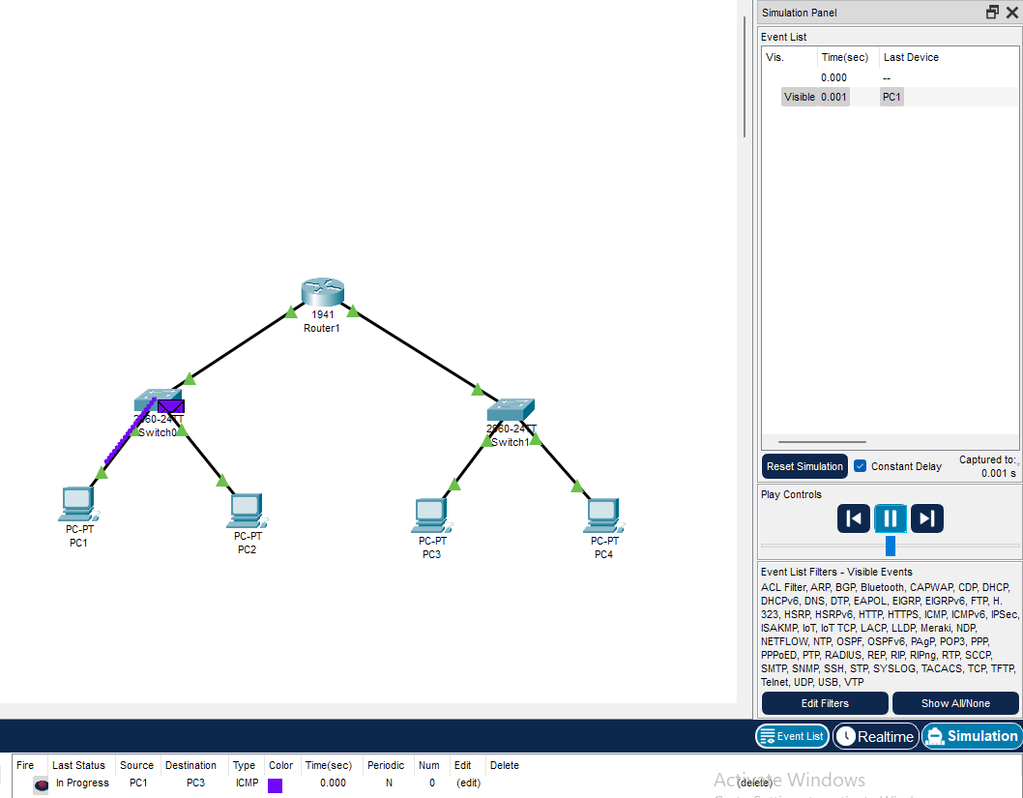
Figure 3.5: Sending a packet from PC1 to PC2 in wired ethernet (fastethernet)

Overall, Cisco Packet Tracer contains a lot of features expected of a high-level network simulator. The customizable features of each device module adds a lot to the realism of a network scenario which unlike the other network simulators, do not account for.

- Use Cases
Cisco Packet Tracer is designed to be beginner friendly and be used as a means to study basic networking concepts. Because of this, it does not have the low-level sophistication and flexibility that NS3 and OMNeT++ have. However, the tool serves its purpose of teaching how networks are formed, the protocols that are used for specific scenarios, and giving an idea on how networks operate in the macro and micro level. Overall, Cisco Packet Tracer can be used in small-scale network research projects, and as an educational tool to be used in schools given its beginner friendly, easy to use framework.

Graphical Network Simulator 3 (GNS3)
GNS3 is a powerful network simulation and emulation platform designed for advanced network design, testing, and troubleshooting. It provides an environment to emulate real-world networks using virtualized devices and supports multiple vendors, making it highly versatile for professionals and students alike.

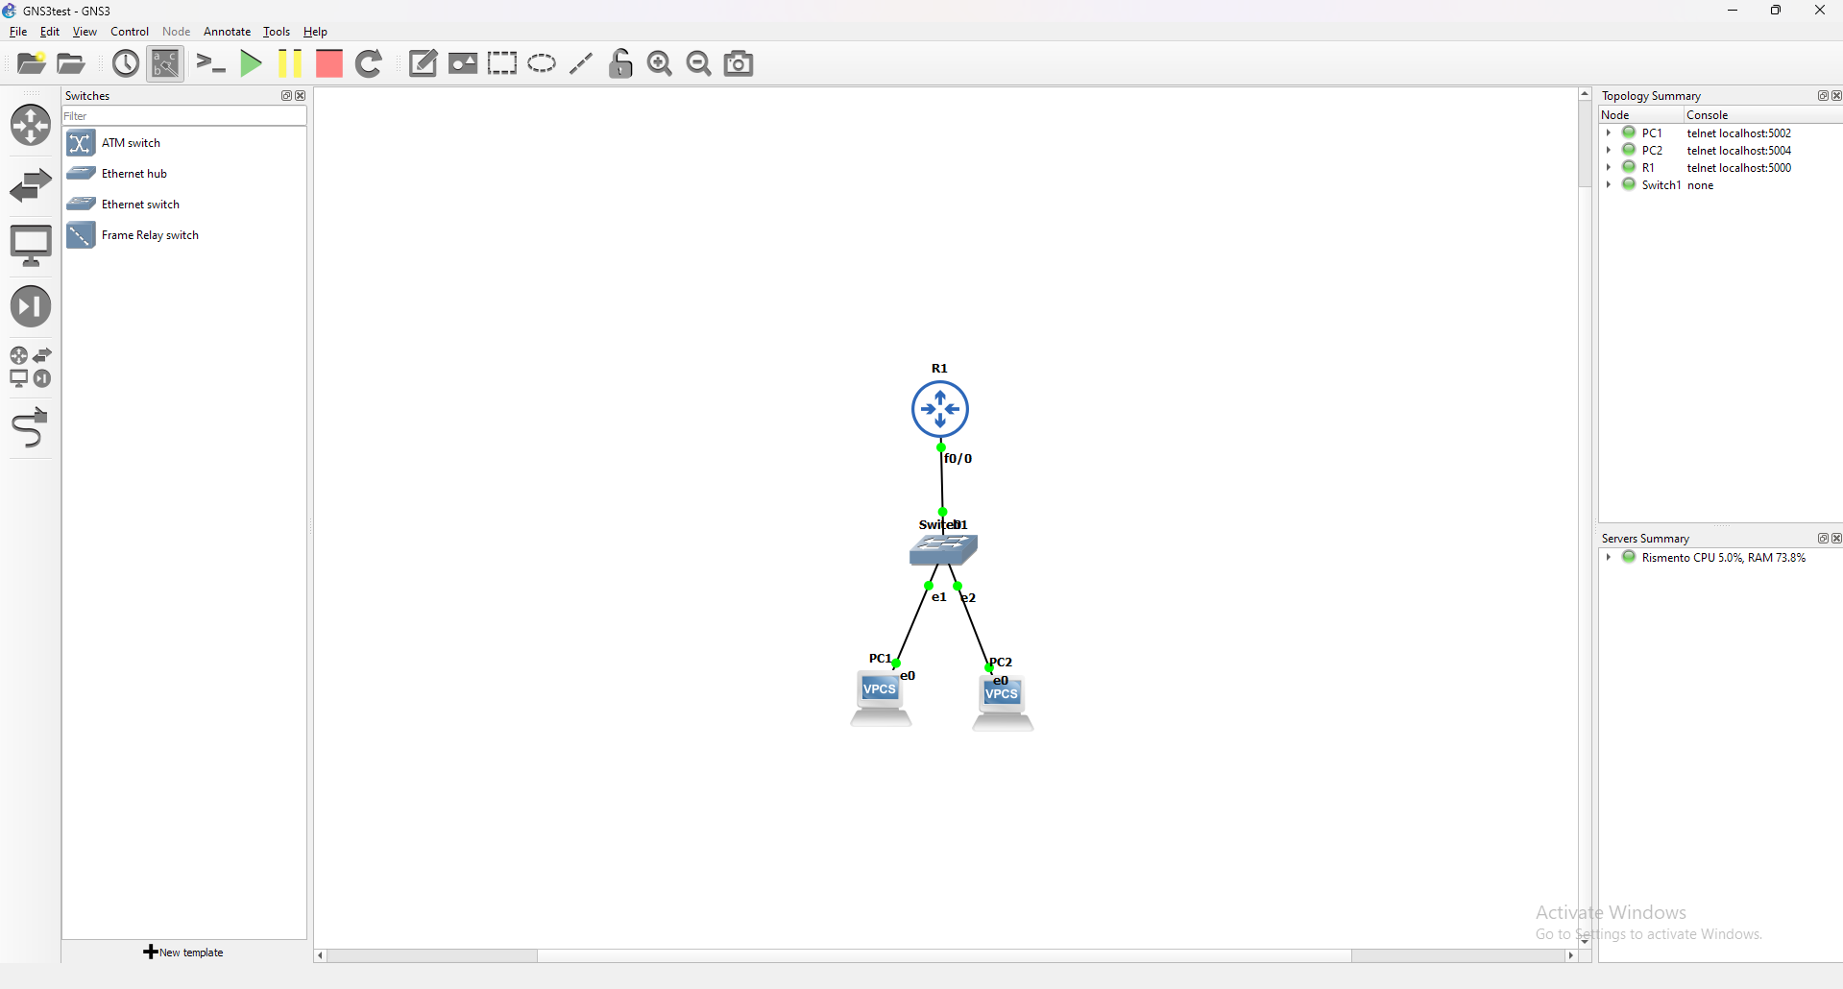
Figure 4.0: GNS3 Interface

- Ease of Use
GNS3’s framework closely resembles that of Cisco Packet Tracer with the implementation of a list of modules that can be dragged and dropped on the open space. However, GNS3 is much more modular due to its open source nature, allowing modules to be added by other developers which unlike Packet Tracer, the modules are already pre-installed. Adding modules to GNS3 requires downloading IOS images of other vendors, in which Cisco images are the most commonly used. Once the modules are installed, they could be dragged and dropped like that of Packet Tracer. The results of the simulator however, can only be seen through the command line interface of the devices used and are not automatically turned into a file nor shown in the IDE itself. The customization for the devices in the network are done by the vendors themselves in making their own IOS images. Overall, the ease of use of GNS3 is similar to that of Cisco Packet Tracer; it can be used in an educational setting to teach modularity in network simulation while retaining the easy to use interface.

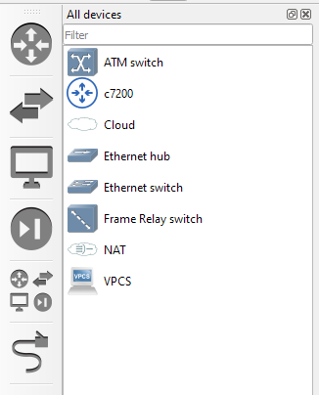
Figure 3.2: List of all installed modules in GNS3

- Tool Abilities
This network simulator does not rely on any scripts for modules, instead using IOS images for device modules. In order to install an IOS image, the user must first find an IOS image suitable for the network scenario to be simulated. An example of an IOS image to install is the Cisco 7200 router. The IOS image requires configuration (RAM, Network Adapters, Idle PC value) then it will be installed, the installed module can be edited afterwards. The interface of GNS3 is similar to that of Cisco Packet Tracer, the modules could be dragged and dropped into the open space and connected into a network. However, GNS3 does not have the physical configuration of Packet Tracer and all configurations are done in the module’s CLI, the settings of which are dependent on the developers.

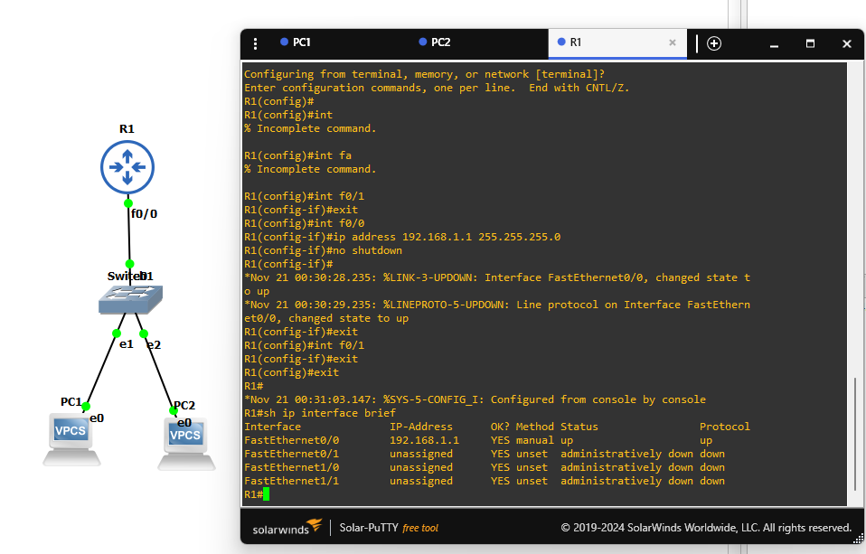
Figure 3.3: CLI settings of a Cisco Router
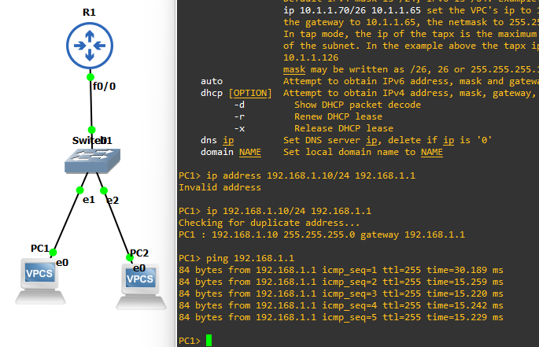
Figure 3.4: PC1 sending ping through wired ethernet (fastethernet)
The main feature of GNS3 that differentiates it from other network simulators is that it emulates the device as an operating system; hence why the IOS images require RAM to be used, Cisco Packet Tracer on the other hand, mimics only how a device works. The ability of GNS3 to run devices that require system resources adds to the realism of the simulation, allowing the user to work on devices in a state of virtualization while working concurrently.

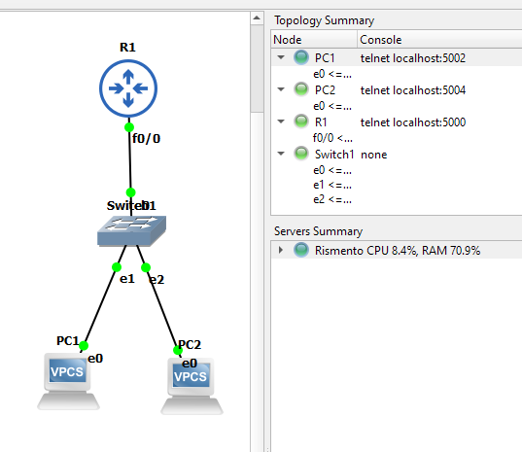
Figure 3.5: Topology summary of a simple GNS3 network

- Use Cases
GNS3 provides a level of sophistication on top of the similar Cisco Packet Tracer in which virtualization is utilized to emulate OS devices in a network topology. This is especially useful in networking education where users are able to work with legitimate software in a controlled network environment along with the easy to use simulation interface. Overall, GNS3 is a network simulation tool not only viable for teaching network software and topology but also useful in professional work given its modular and flexible nature.

Discussion of Findings
After testing the network simulation tools,
Ease of Use
Cisco Packet Tracer: The easiest to use network simulation tool out of the 4. Cisco Packet Tracer is a simulation tool purely designed for educational purposes, used by many networking students to study basic networking concepts such as network connections, protocols, and routing. Along with its easy drag and drop feature, easily customizable modules, and easy to understand simulation interface, Cisco Packet Tracer will continue on being a student’s introductory tool on computer networking.

Tool Abilities
OMNeT++: This tool stood out as a feature-rich, modular, and flexible network simulator able to surpass NS3 with the addition of a graphical simulation interface. OMNeT++ remains to be the best network simulation tool for network development due to its ability to properly simulate many different network scenarios, accurately model network protocols, and to be scaled in either a controlled setting or a real world scenario.

Use Cases
NS3: Aside from OMNeT++, NS3 remains to be the most versatile network simulation tool. With the tool centered around programming network scenarios, the simulations that NS3 could do are bound only by the developer’s affinity in programming and hardware limitations. Supported by a community of developers, aiming to introduce new innovations to the tool, NS3 will continue on being the most commonly used network simulator for professional network research and analysis.

AI-Driven Insights
This research will apply artificial intelligence, specifically through ChatGPT, to enrich regular evaluation models during the assessment of the network simulation tool. By using AI for prompting, insightful answers were derived on the performance of NS3, OMNeT++, Cisco Packet Tracer, and GNS3: ease of use, tool abilities, and use cases.
Ease of Use
The most accessible tool upon prompting the AI model ChatGPT is the Cisco Packet Tracer. ChatGPT emphasized its friendly drag-and-drop interface, with users being able to design and configure network topologies with ease; apparently, without the need for technical skills. This is an educational tool designed specifically, with comprehensive tutorials in tandem with Cisco's Networking Academy to help learners understand network principles on solid ground. Compared to others, like NS3 and OMNeT++, which demand programming skills as well as an understanding of either hard or complex frameworks, the Cisco Packet Tracer has a much lower entry threshold. This makes it apt for all introductory segments and also for instructors to learn and teach networking fundamentals using a practical but not too challenging tool.

Tool Abilities
ChatGPT finds the most powerful tool for simulating complex network scenarios is NS3, whose choice has been based on its feature-rich toolkit, where it supports comprehensive-level packet simulations that accommodate a wide range of protocols and offers significant customizations for various networking scenarios. Since it can simulate the behavior of any wired and wireless network with complete libraries, which support advanced networking functionalities, with the availability of NS3, it becomes an almost foolproof tool for academic and research purposes. Though OMNeT++ has strong modularity, and Packet Tracer has friendly interfaces suitable for education, none of the tools is able to show the depth of profundity and versatility that a complex, complete simulation affords. In turn, GNS3 is much better at emulating real devices but has not optimized abstract network modeling or protocol development. This makes the analysis by ChatGPT emphasize that NS3 has better tool ability, especially for more advanced and development-oriented network simulations.
Use Cases
ChatGPT determined GNS3 to be the most versatile tool for lab testing when compared with NS3, OMNeT++, and Cisco Packet Tracer. The same emulates real devices, having perfect support both in virtual and physical environments. Unlike the rest, GNS3 is quite friendly with actual Cisco IOS images thus giving the user the ability to create complex network topologies similar to those used in an enterprise or service provider network. Flexibility makes it a perfect tool for network design, troubleshooting, and professional training like Cisco CCNA and CCNP. Though the work by NS3 stresses heavily on research-oriented simulations, and OMNeT++ was accentuated on modular academia, focus kills real-world capability. Similarly, Cisco Packet Tracer is more on education than depth required for complexities of real-world professional studies. ChatGPT’s analysis highlights GNS3’s exceptional adaptability across diverse use cases, making it the preferred tool for practical networking applications.

Conclusion

This study concludes that NS3 is best suited for the research and analysis of diverse network scenarios, offering a highly customizable and comprehensive low-level simulation environment. OMNeT++ emerges as the optimal choice for network development, thanks to its extensive module library and user-friendly graphical simulation interface. Cisco Packet Tracer, on the other hand, is recognized as the ideal tool for network learning and light simulations, providing an accessible platform for introductory and educational purposes. On, ChatGPT recognizes Cisco Packet Tracer as an educational tool designed specifically to help learners understand network principles on solid ground. However, ChatGPT declared GNS3 as the most versatile, with its ability to create complex network topologies similar to those used in an enterprise or service provider network as well as serve as an educational tool. Finally, when it comes to Tool Abilities, ChatGPT recognizes NS3 as the most powerful for its feature-rich toolkit, and comprehensive network simulations, able to support a wide range of protocols and various customizations.
The comparative analysis of NS3, OMNeT++, Cisco Packet Tracer, and GNS3 highlights how the design and implementation of network simulation tools influence their use cases. The findings demonstrate that tools like NS3, with its depth and flexibility, excel in advanced research, while simpler tools like Packet Tracer facilitate learning for beginners. This diversity in network simulation tools ensures accessibility to individuals at various skill levels, fostering a more comprehensive understanding of computer networking across educational and professional domains.

References
- A. T, “A Comparative Study of Various Network Simulation Tools,” Aug. 2016. Available: https://www.ijcset.com/docs/IJCSET16-07-08-032.pdf. [Accessed: Nov. 13, 2024]
- A. Ur, R. Khan, S. Bilal, and M. Othman, “A Performance Comparison of Network Simulators for Wireless Networks,” Jul. 2013. Available: https://arxiv.org/pdf/1307.4129
- M. Kabir, S. Islam, M. Hossain, and S. Hossain, “Detail comparison of network simulators,” 2014. doi: https://doi.org/10.13140/RG.2.1.3040.9128
- E. Weingartner, vom Lehn, and K. Wehrle, “A performance comparison of recent network simulators,” 2009, pp. 1–5. doi: https://doi.org/10.1109/ICC.2009.5198657
- V. V and S. Lakshmi, “A case study of various wireless network simulation tools,” Aug. 2018, doi: https://doi.org/10.13140/RG.2.2.32223.30885
- “NS3 Manual Release NS3.43 NS3 project,” 2024. Available: https://www.nsnam.org/docs/release/3.43/manual/NS3-manual.pdf. [Accessed: Nov. 14, 2024]
- L. Campanile, M. Gribaudo, M. Iacono, F. Marulli, and M. Mastroianni, “Computer network simulation with NS3: A systematic literature review,” Electronics, vol. 9, Art. no. 2, 2020, doi: https://doi.org/10.3390/electronics9020272. Available: https://www.mdpi.com/2079-9292/9/2/272
- A. Varga and R. Hornig, “AN OVERVIEW OF THE OMNeT++ SIMULATION ENVIRONMENT,” 2008. Available: https://doc.omnetpp.org/publications/1416290.pdf
- S. Bachmeier, B. Jaeger, and K. Holzinger, “Network Simulation with OMNet++,” Nov. 2020, doi: https://doi.org/10.2313/NET-2020-11-1_08. Available: https://www.net.in.tum.de/fileadmin/TUM/NET/NET-2020-11-1/NET-2020-11-1_08.pdf
- B. Lantz and B. Heller, “A network in a laptop: Rapid prototyping for software-defined networks,” in Proceedings of the 9th ACM SIGCOMM Workshop on Hot Topics in Networks, Oct. 2010, p. 19. doi: https://doi.org/10.1145/1868447.1868466
- Z. Trabelsi and H. Saleous, “Exploring the opportunities of cisco packet tracer for hands-on security courses on firewalls,” 2019, pp. 411–418. doi: https://doi.org/10.1109/EDUCON.2019.8725112
- J. Allison, “Simulation-based learning via cisco packet tracer to enhance the teaching of computer networks,” Dublin, Ireland: Association for Computing Machinery, 2022, pp. 68–74. doi: https://doi.org/10.1145/3502718.3524739. Available: https://doi.org/10.1145/3502718.3524739
- GNS3, “Getting Started with GNS3 | GNS3 Documentation,” mother.github.io. Available: https://docs.gns3.com/do

